An Airline Company Database System

Database Systems Assignment



Student Name: Ciara Power

Student Number: 20072488

Student Name: Kacper Wołoszyn

Student Number: 20071494

Table of Contents

Description 2

Model 3

Table Design 4

# Introduction

The topic chosen for the database design and development is a database system for an Airline company, for example Aer Lingus or Ryanair.

An airline company has various uses for a database, ranging from storing employee details, to scheduling a flight with components integrated from other sections of the database such as planes owned to be used for the flight, flight path to be taken for the flight, and the staff scheduled to work on the flight. These uses, amongst the many others, evidently emphasised the importance of an efficient and well-structured database system.

The model shows a variety of relationships between the tables in the database, as each relationship between areas of an airline is complex and has specific requirements involved. Each table in this model was carefully designed and implemented, with caution applied to constraint conditions and the many different specifications involved with an airline company’s components.

# Project Description

## Description

The database is created for the use of an individual airline, and contains tables documenting many areas such as planes owned by the company, scheduled flights by the company, flight paths set out by the company, employees of the company, and many more.

The connections between data in an airline database system are vital in maintaining the efficient database, which is key to a successful airline company. For example, an employee working for the company must have a contract associated with them, in order to ensure contract dates and proposed weekly hours are upheld.

Information must be stored about each plane, employee, airport, supply company, to name but a few.

# Model

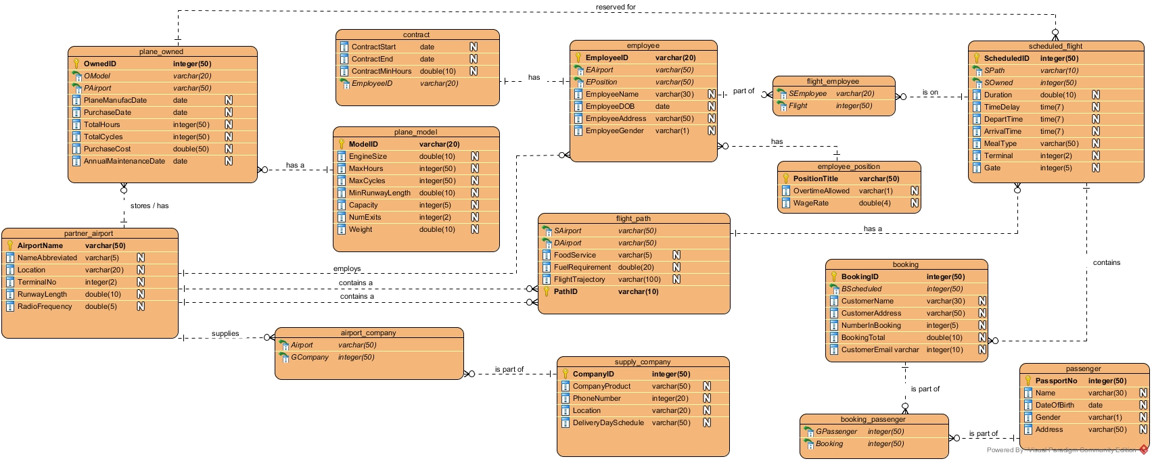

* Plane is reserved for many scheduled flight where as a scheduled flight has only one plane.
* Plane has one specific model; plane model has many planes.
* Partner airport has and stores many planes owned, but a plane is stored at one partner airport.
* Partner airport employs many employees but employees are employed for one partner airport.
* Partner airport contains many flights path source airports, source airport can only have 1 airport.
* Partner airport has many destination airports, destination airports have only one partner airport.
* Partner airport is supplied by a group of airport companies, but only one group supplies the airport
* An airport company group can have one company that supplies it, but a company can be part of many groups.
* Flight path has many scheduled flights, i.e. one path many flights fly on, scheduled flight has one specific flight path.
* Scheduled flight has many flight employees, which are grouped in flight employee, but a specific group can be part of one flight.
* Employee can be part of many flight employee groups, but flight employee group takes in one specific employee.
* Employee has one position he is responsible for, positions have many employees.
* Employee has one specific contract she or he is on, contract can be linked to one employee, each contract is different for other employees.
* Scheduled flight contains many bookings, bookings can be made for one specific scheduled flight.
* Passenger can be part of many booking groups, there is one booking group for a specific passenger.
* A group of passengers is on one booking, whereas booking can have many booking groups.

|  |  |  |  |
| --- | --- | --- | --- |
| plane_owned | | |  |
| NAME | VARIABLE TYPE | CONSTRAINT | DESCRPTION |
| OwnedID | Integer(50) | Primary key, not null | The ID of plane |
| OModel | Varchar(20) | Foreign key, not null | The model type |
| PAirport | Varchar(50) | Foreign key, not null | Where the plane is located |
| PlaneManufacDate | Date | PlaneManufacDate>'1974-01-01' AND PlaneManufacDate< SYSDATE() | Manufacture Date |
| PurchaseDate | Date | PurchaseDate > PlaneManufacDate AND PurchaseDate<= SYSDATE() | Purchase Date |
| TotalHours | Integer(50) |  | Hours spent in the air |
| TotalCycles | Integer(50) |  | Number of times it has completed a flight |
| FirstMaintenanceDate | Date | FirstMaintenanceDate>=PurchaseDate AND FirstMaintenanceDate<= SYSDATE() | The first maintenance date of plane |
| PurchaseCost | Double |  | How much the plane was |

|  |  |  |  |
| --- | --- | --- | --- |
| parter_airport | | |  |
| NAME | VARIABLE TYPE | CONSTRAINT | DESCRIPTION |
| AirportName | Varchar(50) | Primary key, not null | Name of airport |
| NameAbbreviated | Varchar(5) |  | An abbreviation of the name of the airport |
| Location | Varchar(20) |  | Where the airport is located |
| TerminalNo | Integer(2) |  | Terminal Number |
| RunwayLength | Double |  | What length the runway is |
| RadioFrequency | Double |  | The radio frequency for an airport |

|  |  |  |  |
| --- | --- | --- | --- |
| plane_model | | |  |
| NAME | VARIABLE TYPE | CONSTRAINT | DESCRIPTION |
| ModelID | Varchar(20) | Primary key, not null | The model ID of the plane |
| EngineSize | Double |  | Engine Size of the plane |
| MaxHours | Integer(50) |  | How many hours it can spend in the air |
| MaxCycles | Integer(50) |  | How many flights can a plane have |
| MinRunwayLength | Double |  | Minimum Runway length the plane can land on |
| Capacity | Integer(5) |  | How many people plane can hold |
| NumExits | Integer(2) |  | Number of exits on the plane |
| Weight | Double |  | Weight of the plane |

|  |  |  |  |
| --- | --- | --- | --- |
| flight_path | | | |
| NAME | VARIABLE TYPE | CONSTRAINT | DESCRIPTION |
| PathID | Varchar(10) | Primary key, not null | The Path id of a fligh |
| SAirport | Varchar(50) | Foreign key, not null | The source airport |
| DAirport | Varchar(50) | Foreign key, not null | The destination airport |
| FoodService | Varchar(5) | FoodService="Yes" OR FoodService="No" | If food service is available on the flight path |
| FlightTrajectory | Varchar(100) |  | Which countries the flight takes place over |

|  |  |  |  |
| --- | --- | --- | --- |
| airport_company | | | |
| NAME | VARIABLE TYPE | CONSTRAINT | DESCRIPTION |
| Airport | Varchar(50) | Foreign key, not null | The name of the airport that a group of companies supplies to |
| GCompany | Integer(50) | Foreign key, not null | Group of companies that have been placed into this table |

|  |  |  |  |
| --- | --- | --- | --- |
| supply_company | | | |
| NAME | VARIABLE TYPE | CONSTRAINT | DESCRIPTION |
| CompanyID | Integer(50) | Primary key, not null | Company ID of the supply company |
| CompanyProduct | Varchar(50) |  | Product the company is supplying |
| PhoneNumber | Integer(20) |  | Phone number of company |
| Location | Varchar(20) |  | Location of company |
| DeliveryDaySchedule | Varchar(50) | DeliveryDaySchedule="Monday" OR "Tuesday" OR "Wednesday" OR "Thursday" OR "Friday" OR "Saturday" OR "Sunday" | Which day the delivery takes place |

|  |  |  |  |
| --- | --- | --- | --- |
| employee | | | |
| NAME | VARIABLE TYPE | CONSTRAINT | DESCRIPTION |
| EmployeeID | Varchar(20) | Primary key, not null | PPS number of the employee |
| EAirport | Varchar(50) | Foreign key, not null | The airport base the employee is based in |
| EPosition | Varchar(50) | Foreign key, not null | The position the employee oversees |
| EmployeeName | Varchar(30) |  | Name of employee |
| EmployeeDOB | Date | (SYSDATE()-EmployeeDOB>=18 | Date of birth of employee, must be bigger then 18 |
| EmployeeAddress | Varchar(50) |  | Address of Employee |
| EmployeeGender | Varchar(1) | EmployeeGender="M" OR EmployeeGender="F" | Gender of Employee |

|  |  |  |  |
| --- | --- | --- | --- |
| contract | | | |
| NAME | VARIABLE TYPE | CONSTRAINT | DESCRIPTION |
| CEmployeeID | Varchar(20) | Foreign key, not null | Employee ID |
| ContractStart | Date | ContractStart <= SYSDATE() | Start date of contract |
| ContractEnd | Date | ContractEnd > ContractStart AND ContractEnd>SYSDATE() | End date of contract |
| ContractMinHours | Double |  | Minimum Hours on contract |

|  |  |  |  |
| --- | --- | --- | --- |
| flight_employee | | | |
| NAME | VARIABLE TYPE | CONSTRAINT | DESCRIPTION |
| SEmployee | Varchar(20) | Foreign key, not null | The employee Id of one employee |
| Flight | Integer(50) | Foreign key, not null | Employees on a specific flight |

|  |  |  |  |
| --- | --- | --- | --- |
| employee_postion | | | |
| NAME | VARIABLE TYPE | CONSTRAINT | DESCRIPTION |
| PositionTitle | Varchar(50) | Primary key, not null | The position the employee has in the company |
| OvertimeAllowed | Varchar(1) | OvertimeAllowed="Y" OR OvertimeAllowed="N" | If overtime is allowed in a specific position, i.e. pilots due to a health risk are not allowed overtimes |
| WageRate | Double | wageRate>= 9.15 | The amount the employee will earn at a specific position |

|  |  |  |  |
| --- | --- | --- | --- |
| scheduled_flight | | | |
| NAME | VARIABLE TYPE | CONSTRAINT | DESCRIPTION |
| ScheduledID | Integer(50) | Primary key, not null | The ID of the flight |
| SPath | Varchar(10) | Foreign key, not null | The path the flight will take |
| SOwned | Integer(50) | Foreign key, not null | The plane owned that will be flown on this specific flight |
| Duration | Double |  | Duration of flight |
| TimeDelay | Double |  | If the flight has a time delay in decimal point |
| DepartTime | DateTime | DepartTime<SYSDATE() | Departure time of the flight |
| ArrivalTime | DateTime | ArrivalTime > DepartTime | The arrival time of the flight |
| MealType | Varchar(50) | MealType= "Breakfast" OR "Lunch" OR "Dinner" or "None" | The meal type on a scheduled flight |
| Terminal | Integer(2) |  | Terminal of the arrival airport |
| Gate | Integer(5) |  | Gate of the specified terminal |

|  |  |  |  |
| --- | --- | --- | --- |
| booking | | | |
| NAME | VARIABLE TYPE | CONSTRAINT | DESCRIPTION |
| BookingID | Integer(50) | Primary key, not null | The id of the booking |
| BScheduled | Integer(50) | Foreign key, not null | The id of the scheduled flight |
| CustomerName | Varchar(30) |  | Name of customer |
| CustomerAddress | Varchar(50) |  | Address of customer |
| NumberInBooking | Integer(5) | NumberInBooking !=0 | The number of people in a booking |
| BookingTotal | Double | BookingTotal !=0 | Total amount |
| CustomerEmail | Varchar(50) |  | Email of customer |

|  |  |  |  |
| --- | --- | --- | --- |
| booking_passenger | | | |
| NAME | VARIABLE TYPE | CONSTRAINT | DESCRIPTION |
| GPassenger | Integer(50) | Foreign key, not null | Passport number of the booked passenger |
| Booking | Integer(50) | Foreign key, not null | Booking Id of the flight |

|  |  |  |  |
| --- | --- | --- | --- |
| passenger | | | |
| NAME | VARIABLE TYPE | CONSTRAINT | DESCRIPTION |
| PassportNo | Integer(50) | Primary Key, not Null | Passport number of passenger |
| Name | Varchar(50) |  | Name of passenger |
| DateOfBirth | Date | DateOfBirth<SYSDATE() | Date of birth of passenger |
| Gender | Varchar(1) | Gender="M" OR Gender="F" | Gender of passenger |
| Address | Varchar(50) |  | Passenger’s address |